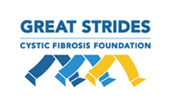

Dear Friends and Family:
On May 31st, I will be participating in Great Strides, a walk put on by the Cystic Fibrosis Foundation to fund life-saving research for CF. Cystic Fibrosis is a devastating genetic disease involving the buildup of thick, sticky mucus that clogs the lungs, causing serious respiratory damage, and obstructs the pancreas, leading to nutritional deficiencies. The daily battle to fight this disease is expensive, time consuming, and unrelenting. And even with a strong fight, the median age of survival for people with CF is only in the thirties. What is needed is a cure!
I am eager to be part of Great Strides and I will be walking with Team Jonah in honor of twenty year old Jonah Ostermann. Since its first walk in 2006, Team Jonah has raised just over $450,000 for the CF Foundation! We hope to raise at least $20,000 this year. As a walker, I want to do my part to raise as much as I can toward this very ambitious goal.
Here is how you can help…please make a donation that will help find a cure for Jonah and the 40,000 other people in the United States who battle this awful disease every day. The CF Foundation is a very efficient organization and nearly 90 percent of every dollar raised is available for the investment in life-saving programs to support research, care, and education. This is an exciting time - research is currently being done on therapies that won’t just manage the symptoms of CF, but may cure it by reversing the basic defect. This research is very expensive to fund, but the rewards are priceless.
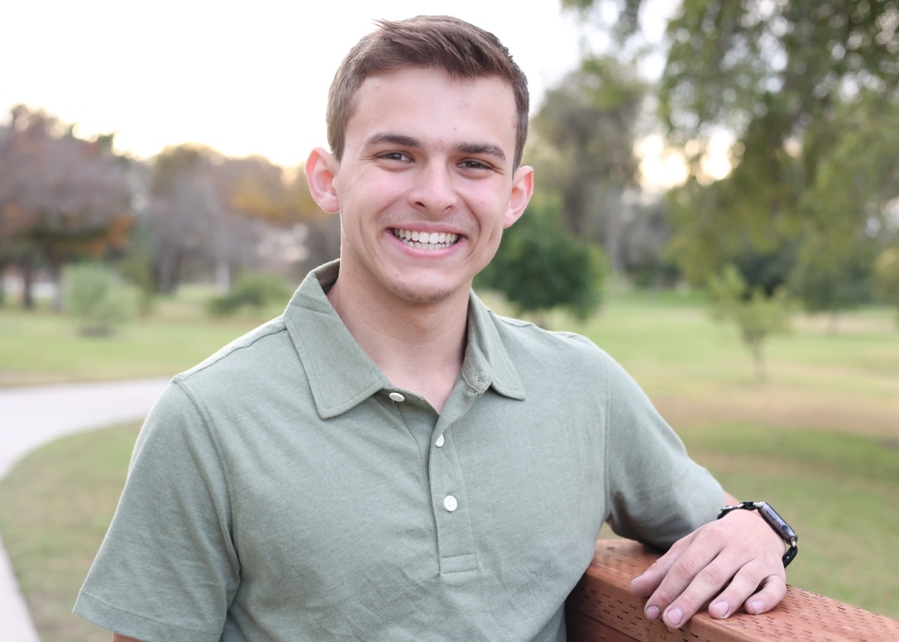
Please take a moment to show your support in my endeavor by making a donation today. The easiest way is to visit Team Jonah’s website at TeamJonah.com and click on my name to make a secure online donation. Or if you prefer, you may write a check payable to the Cystic Fibrosis Foundation and mail it to: Team Jonah, 7855 Garner St., Long Beach, CA 90808. Please put my name in the memo line so that the donation can be credited toward my personal fundraising goal.
Any amount you can donate will be greatly appreciated and all contributions are 100 percent tax deductible.
Thank you for your support and generosity.
Sincerely,

